**Keycloak Setup**

1. Browse to <http://localhost:8080/>
2. You will see the window to configure initial admin user.

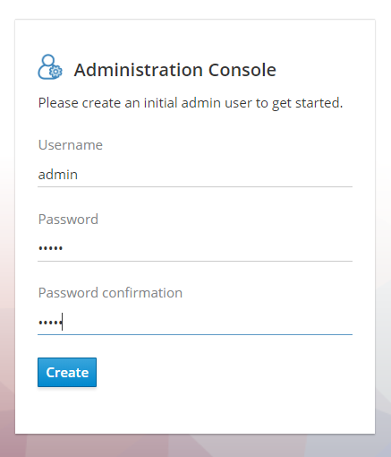

1. For easiness, create an admin user with username & password as ***admin***.
2. Login with this user by clicking on ***Administration Console***.
3. After login, you will see ***master*** realm as active realm
4. Click on ***Add Realm*** button

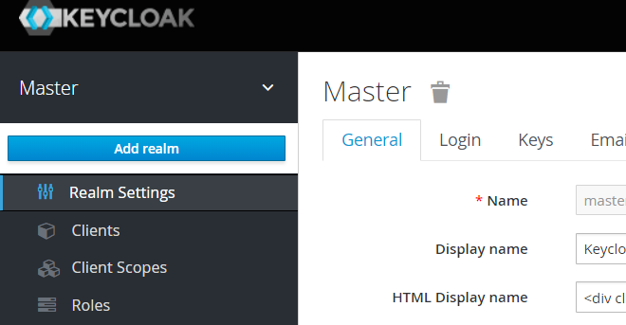

1. 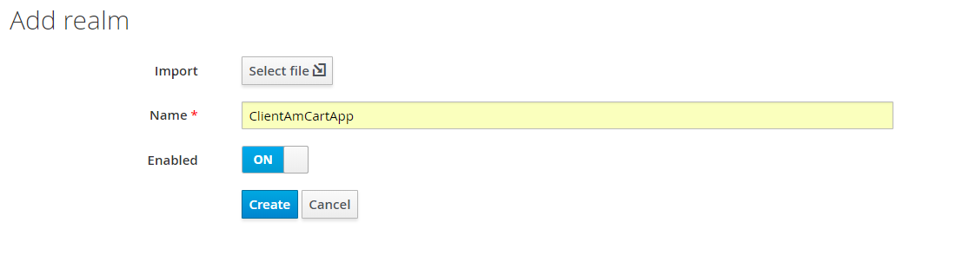Add Realm

* Name: ***ClientAmCartApp***
* Enabled: ***ON***

1. Go to ***Clients*** section

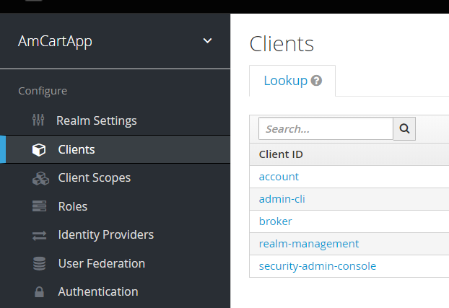

1. Click on ***Create*** button.
2. Click on ***Select File*** button next to ***Import*** label.
3. Import ***AmCartApp_client.json*** file. ***Client ID*** will be auto populated.
4. 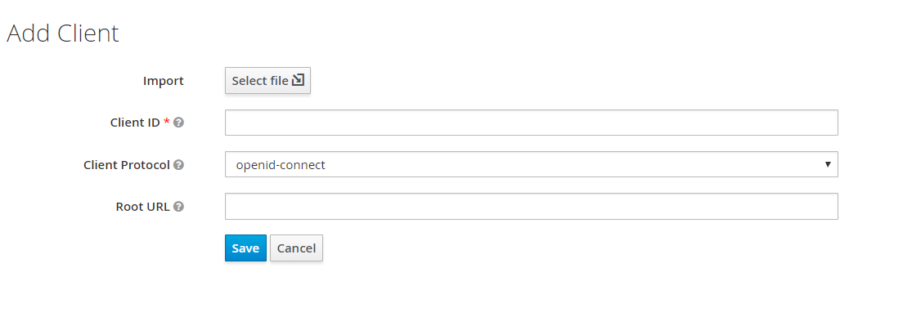Click on ***Save*** button.
5. Now go to ***Import*** section under ***Manage***.

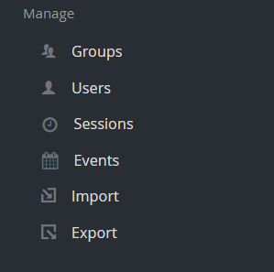

1. Import ***client_config.json*** file.

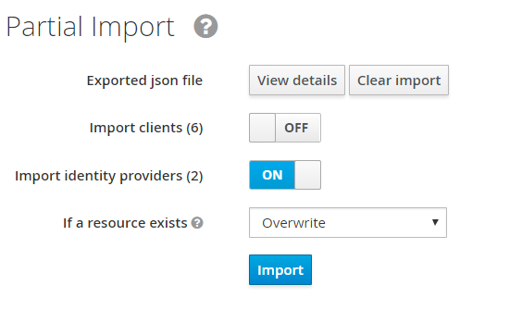

1. Turn ***Import client*** toggle button to ***OFF***
2. Turn ***Import Identity Providers*** button to ***ON***.
3. Select ***If a resource exists*** dropdown value to ***Overwrite***.
4. Click on ***Import*** button.
5. Go to ***Identity Providers*** section under ***Configure***.

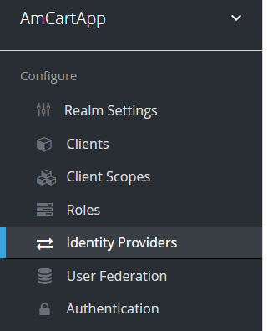

1. 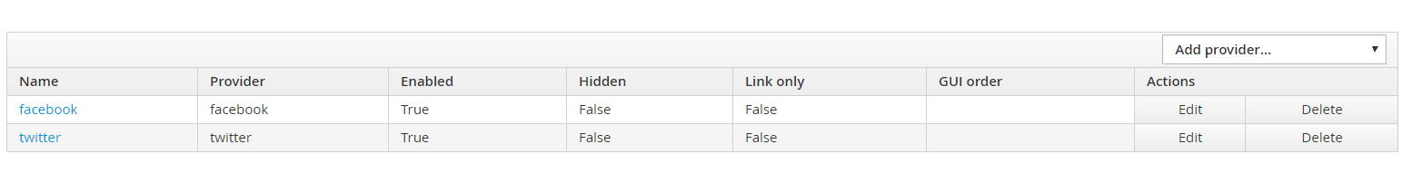Click on ***facebook***.
2. 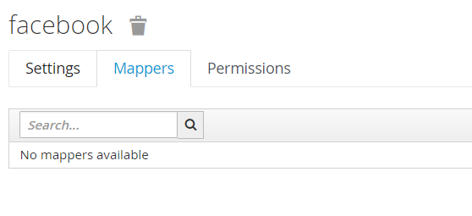Go to ***Mappers***
3. Click on ***Create***.

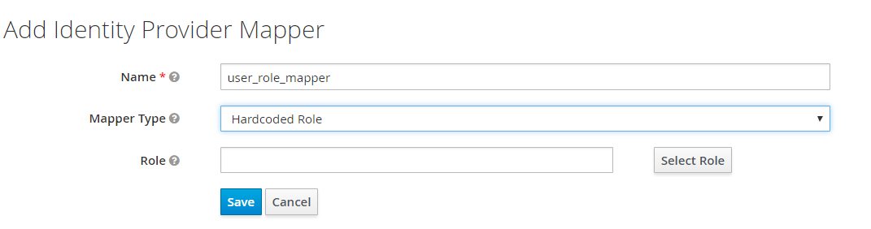

1. Enter ***Name*** as ***user_role_mapper***.
2. Select ***Mapper Type*** as ***Hardcoded Role***.
3. Click on ***Select Role*** button.

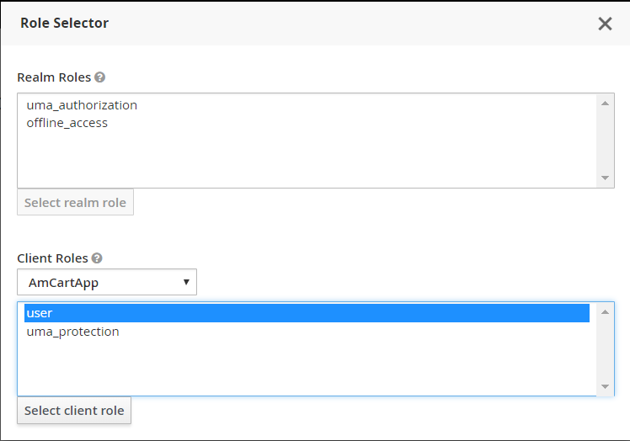

1. Select ***AmCartApp*** in dropdown under ***Client Roles*** label.
2. Select ***user*** role in the list
3. Click on ***Select client role*** button.
4. Click on ***Save*** button.
5. Repeat steps 21-29 for ***twitter*** Identity Provider.
6. Perform steps as mentioned in ***Configure AmCart Theme in Keycloak*** document in ***Updates\16-01-2019*** directory.